|  |  |
| --- | --- |
| *Date | 27 September 2023 |
| Team ID |  |
| Project Name | AI based diabetes prediction |
| Maximum Marks |  |

**Ideation Phase**

**Abstract:**

This study proposes a machine learning approach for predicting the risk of diabetes using an AI model trained on a large dataset of patient records. The model utilizes various features such as age, BMI, blood pressure, and glucose levels to accurately predict the likelihood of developing diabetes. The results show promising accuracy and potential for early detection and prevention of diabetes through AI technology.

Diabetes Mellitus is among critical diseases and lots of people are suffering from this disease. Age, obesity, lack of exercise, hereditary diabetes, living style, bad diet, high blood pressure, etc. can cause Diabetes Mellitus. People having diabetes have high risk of diseases like heart disease, kidney disease, stroke, eye problem, nerve damage, etc.

Current practice in hospital is to collect required information for diabetes diagnosis through various tests and appropriate treatment is provided based on diagnosis.

Big Data Analytics plays an significant role in healthcare industries. Healthcare industries have large volume databases. Using big data analytics one can study huge datasets and find hidden information, hidden patterns to discover knowledge from the data and predict outcomes accordingly.

In existing method, the classification and prediction accuracy is not so high. In this paper, we have proposed a diabetes prediction model for better classification of diabetes which includes few external factors responsible for diabetes along with regular factors like Glucose, BMI, Age, Insulin, etc. Classification accuracy is boosted with new dataset compared to existing dataset. Further with imposed a pipeline model for diabetes prediction intended towards improving

* AI-based diabetes prediction project, here are a few steps you can follow:

1.Data Collection:

Gather a comprehensive dataset that includes medical records, lifestyle information, and genetic data of individuals with and without diabetes.

2.Data Preprocessing:

.               Clean and preprocess the data, handling missing values, normalizing features, and encoding categorical variables.

3. Feature Selection:

Identify the most relevant features that contribute to diabetes prediction. This can be done through statistical analysis or using feature selection algorithms.

4. Model Development:

Choose an appropriate machine learning algorithm, such as logistic regression, random forest, or a deep learning model, and train it using your preprocessed data. Optimize the model's hyperparameters to achieve the best performance.

5. Evaluation:

Assess the performance of your diabetes prediction model using evaluation metrics such as accuracy, precision, recall, and area under the ROC curve. Consider using cross-validation to ensure robustness.

6. Interpretation:

Analyze the model's feature importance to gain insights into the factors influencing diabetes prediction. This can help in understanding the underlying mechanisms and identifying potential risk factors.

7. Deployment:

Once you have a reliable model, you can deploy it as a diabetes prediction system. This could involve creating a user-friendly interface or integrating it into existing healthcare systems.

**Define the Problem Statements**

**Customer Problem Statement Template:**

Patients with the potential of diabetes have to go through a series of tests and exams to diagnose the disease properly. These tests might embody redundant or inessential medical procedures, that cause complications and wastage of time and resources.

The burden of this sickness on the economy way exceeds the direct medical prices within the care sector because diabetes reduces the standard of life and hinders labor productivity.

The absence of a correct diagnosis scheme, deficiency of economic means, and a general lack of awareness represent the main reasons for these negative effects.

Hence, preventing the sickness altogether through early detection may doubtless cut back a considerable burden on the economy and aid the patient in diabetes management.

|  |  |
| --- | --- |
| **Early Detection of Diabetes Risk:** | Problem Statement Develop an AI based predictive model to identify individuals at an early stage of diabetes risk, allowing for timely intervention and prevention strategies. |
| **Personalized Diabetes Risk Assessment:** | Problem statement create an AI system that provides personalized diabetes risk assessments by considering a patients medical history , lifestyle factors and genetic predispositions |
| **Real-Time Glucose Level Prediction:** | Build an AI algorithm that predicts real-time glucose levels in diabetes patients, enabling better insulin dosing and glycemic control. |
| **Integrating Wearable Data:** | Integrate data from wearable devices such as continuous glucose monitors and activity trackers into AI models to enhance diabetes risk prediction and management. |

The goal of this project is to develop an AI model that can accurately predict the risk of diabetes in individuals based on their health data. By analyzing factors such as age, BMI, blood pressure, and glucose levels, the AI system aims to provide early detection and proactive intervention to prevent the onset of diabetes. The challenge lies in training the model on a diverse dataset and optimizing its performance to ensure reliable and accurate predictions.

**Empathize & Discover**

**Empathy Map Canvas :**

An empathy map is a collaborative tool teams can use to gain a deeper insight into their customers. Much like a user persona, an empathy map can represent a group of users, such as a customer segment. The empathy map was originally created by Dave Gray and has gained much popularity within the agile community.

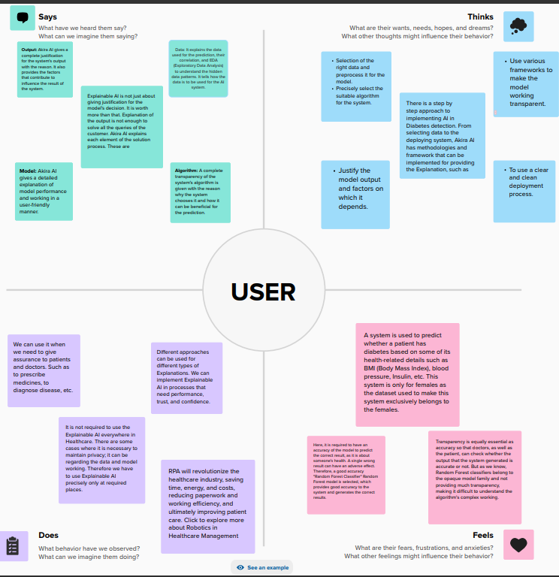

**Brainstorms & Idea Prioritization**

Brainstorms &Idea Prioritization Template:

